**Introduction to Computing and Data Science** 

**Department of Computer Science**

**University of Engineering and Technology Lahore**

**________________________________________________________________________**

**Learning Outcomes:**

* Python Installation and getting familiar with Jupyter Notebook

# 

# Introduction

In this first lab of Introduction to Computing and Data Science, we shall learn about the installation of our python environment that shall be used throughout the semester to perform various tasks for problem-solving.

# Setting up Python Environment

The first thing you need to do, to learn Python for Data Science, is to install Python and a suitable Integrated Development Environment (IDE) for coding in Python. At the end of this manual, you will be able to start coding in Python.

## Setting up Python

**1. Download Python Executable File**

To initiate Python installation on your system, you first have to download and run the Python.exe file. For this, navigate to the Python official website and download the latest version of Python.

a. Open your web browser (Chrome, Firefox, etc.)

b. Go to the website:<https://www.python.org/>

c. Go to the downloads for windows section

d. Click on Python 3 and download ‘Windows installer (64-bit)’. At the time of the download, the file was 27.5 MB.

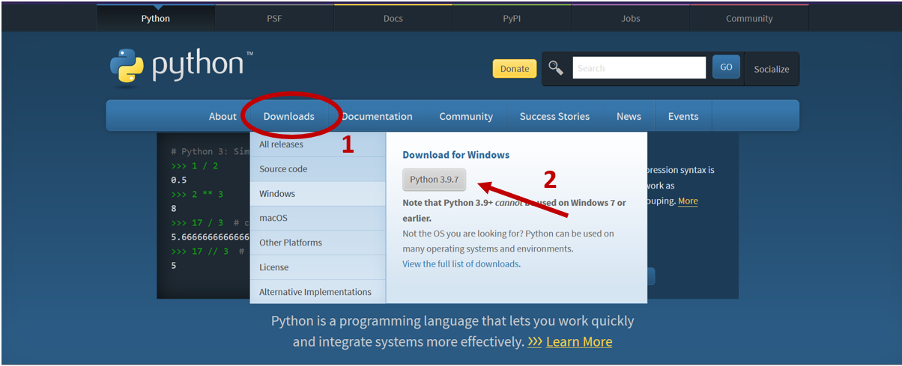

**2. Running Python Executable File**

a. Now, go to the directory where you have downloaded the file and open it. (OR press ‘**ctrl + j**’ on your browser, it will show your downloads, double click on the installer).

b. Click on **‘Install Now**’ with the shown settings.

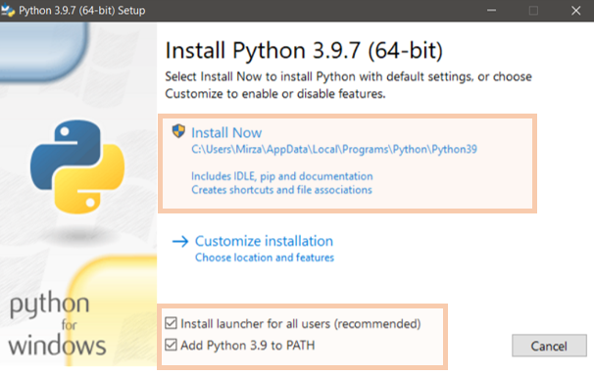

c. After installation, click on the **‘Close’** button. Your Python installation is successful.

**3. Check Installation**

a. To verify your installation, go to the command prompt (type **‘cmd’** in the Search box).

b. Now type, “**Python –V**” to check the version of Python installed.

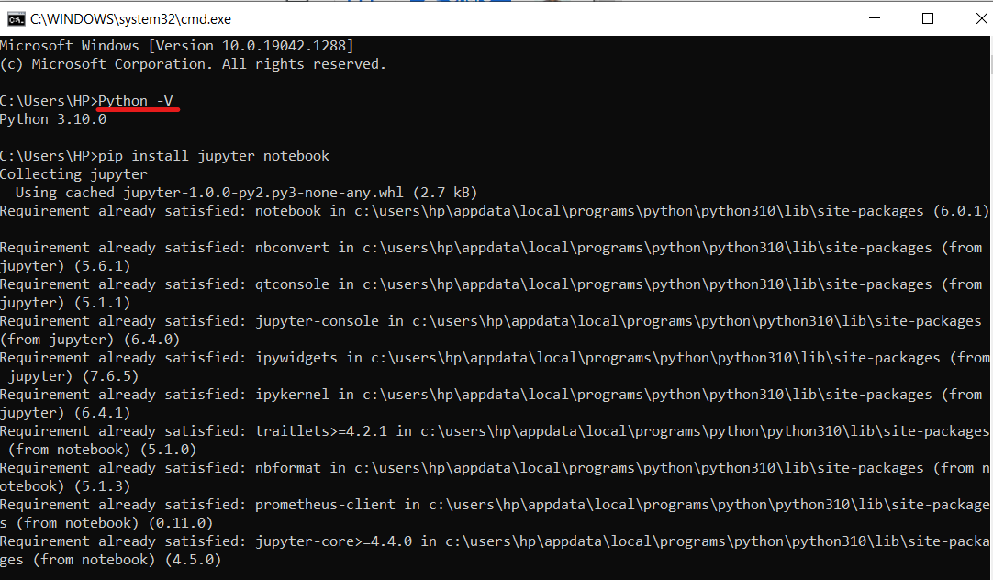

**2.** **Setting up Jupyter Notebook**

Jupyter Notebook is an IDE used mostly by Data Scientists. It also supports many file formats like JSON, CSV, jpeg, etc which is very useful when working with different forms of data.

**1. Installing Jupyter Notebook**

a. Open your command prompt.

b. Type ‘**pip install jupyter notebook**’.

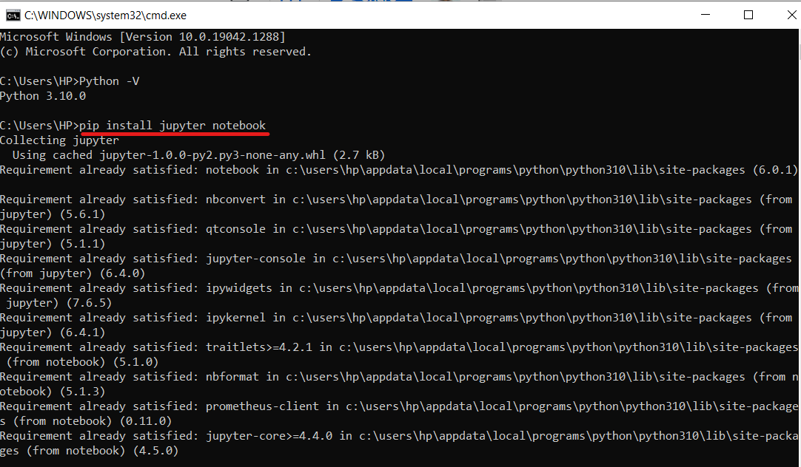

After the installation is complete, just type ‘**jupyter notebook**’ on your command prompt and it will run the jupyter notebook on your system.

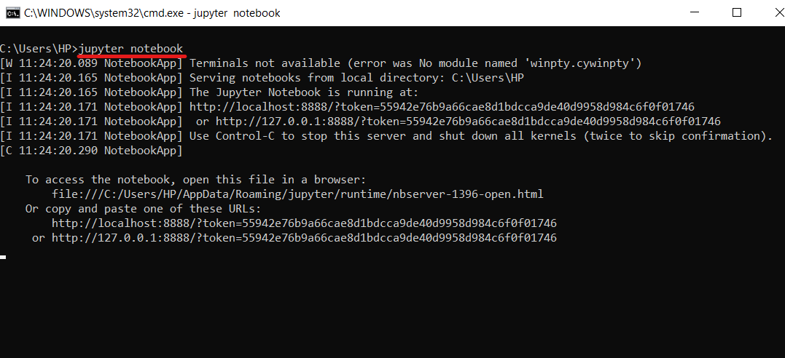

On successful completion of installation, it would open the notebook in your default web browser. The main screen of the notebook looks like the below-mentioned screenshot.

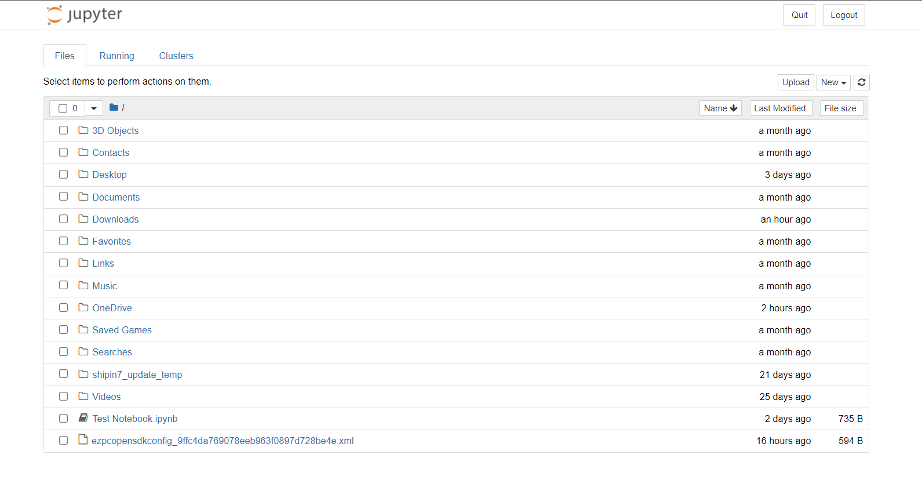

To create your first notebook, click on the “**new**” button and select the ‘**Python 3**’ from the drop-down menu.

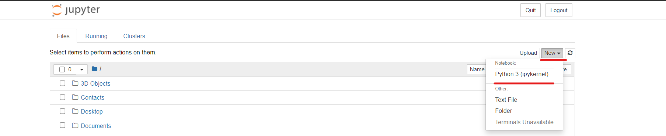

This will open the **following window** for you.

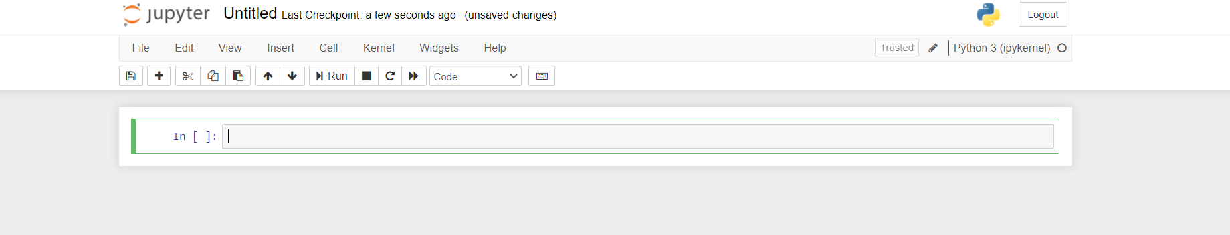

Now, you can rename the notebook by clicking on the “Untitled” section at the top or may choose not to.

Let’s start writing some code.

For this,

a. Write Python code on the line.

b. Press ‘**Shift + Enter**’ on your keyboard to execute this line.

c. Your output will be shown below the line

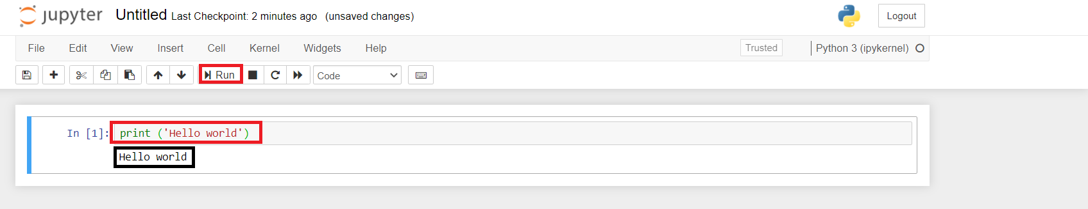

**Congratulations, You have successfully installed and learned the Jupyter Notebook.**

**Happy Coding Ahead!**